LAB 1

DEPLOYING DVWA WEBSITE ON THE LINUX SERVERS

# Objective

Students will learn to:  
- Install and configure a LAMP stack (Linux, Apache, MySQL/MariaDB, PHP)  
- Download and deploy DVWA  
- Configure required permissions and database settings  
- Test and verify DVWA deployment

# Prerequisites

- A working Ubuntu Server (20.04+ recommended)  
- Internet access  
- Root or sudo privileges

Note: Depending on the Linux distribution, the command line may be different.

**Note:** Command explaination is highlighted in yellow.

# PART 1. Deploying the website on a server

# Step 1: Update the Server

sudo apt update && sudo apt upgrade -y

To download and apply the latest version of kali linux

# Step 2: Install Apache, MySQL, and PHP (LAMP Stack)

sudo apt install apache2 mysql-server php php-mysqli php-gd libapache2-mod-php git -y  
Replace the command above with:

sudo apt install apache2 mariadb-server php php-mysql php-gd libapache2-mod-php git -y

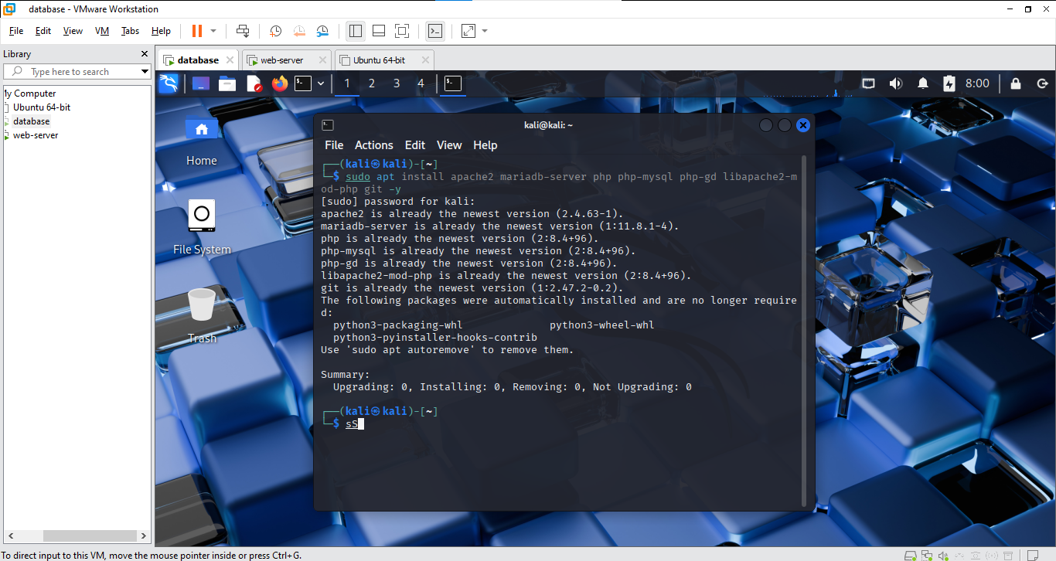  
sudo systemctl enable apache2  
sudo systemctl start apache2  
  
sudo systemctl status apache2: to show apache2 status(turned on or not)

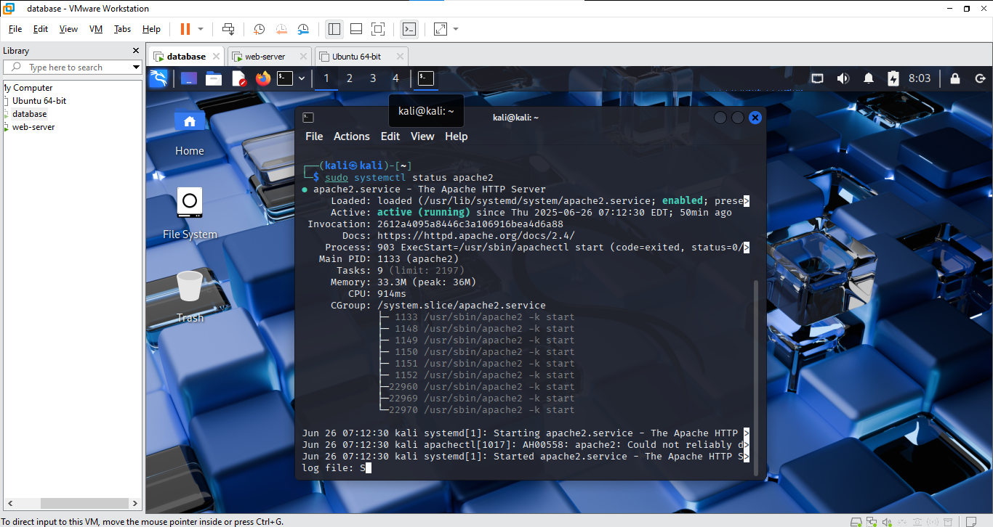

# Step 3: Clone the DVWA Repository

cd /var/www/html  
sudo git clone https://github.com/digininja/DVWA.git: to download DVWA from github  
  
sudo chown -R www-data:www-data /var/www/html/DVWA: change the ownership of the directory to users in www-data group  
sudo chmod -R 755 /var/www/html/DVWA: Set the permission of each type of user in the group(775 means owners can read, write, and execute the properties in the directory, while group members and others can only read and execute)

# Step 4: Configure DVWA

cd /var/www/html/DVWA/config  
sudo cp config.inc.php.dist config.inc.php: to copy the content of config.inc.php.dist to config.inc.php  
sudo nano config.inc.php  
  
Edit the following lines:  
$_DVWA[ 'db_user' ] = 'dvwa';  
$_DVWA[ 'db_password' ] = 'dvwa';

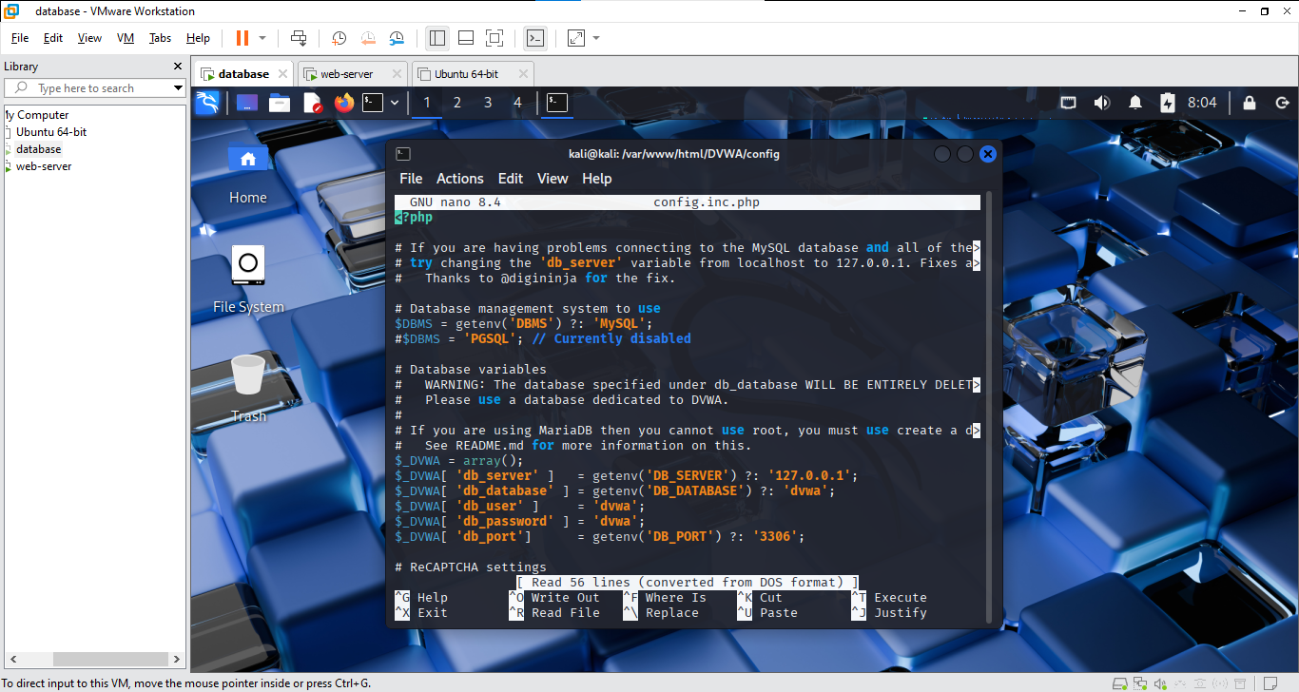

# Step 5: Create the DVWA Database

sudo mysql  
  
Then run:  
CREATE DATABASE dvwa;: create a database named dvwa  
CREATE USER 'dvwa'@'localhost' IDENTIFIED BY 'dvwa';: add a user named dvwa into the dvwa database  
GRANT ALL PRIVILEGES ON dvwa.* TO 'dvwa'@'localhost';: give all permissions to the user named dvwa  
FLUSH PRIVILEGES;: apply changes to the database  
EXIT;

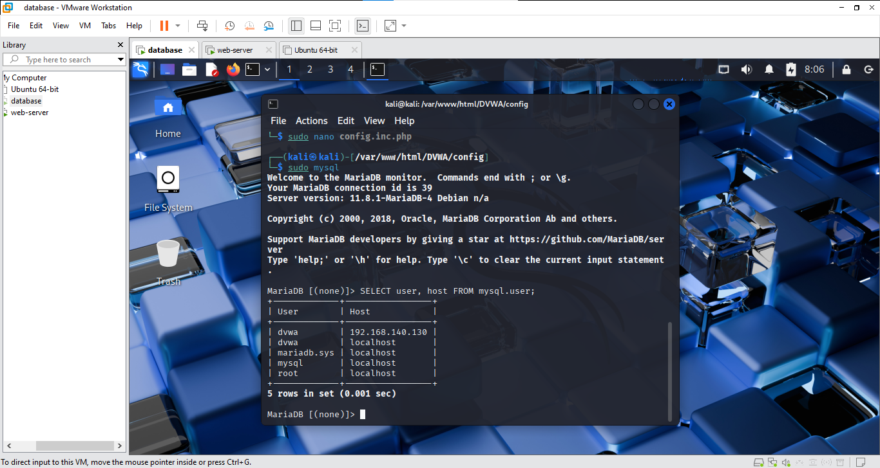

# Step 6: Configure PHP

sudo nano /etc/php/*/apache2/php.ini  
  
Find and set:  
allow_url_include = On

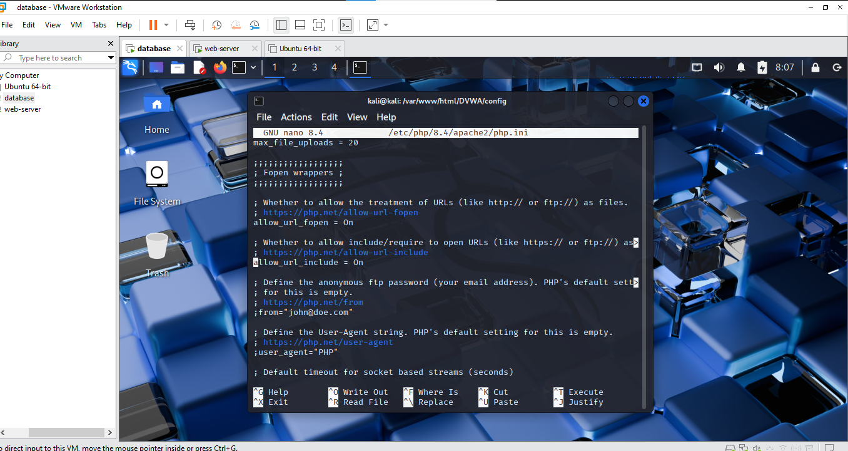  
  
Then restart Apache:  
sudo systemctl restart apache2

# Step 7: Access DVWA

Visit: http://<your-server-ip>/DVWA/setup.php  
Click 'Create / Reset Database'



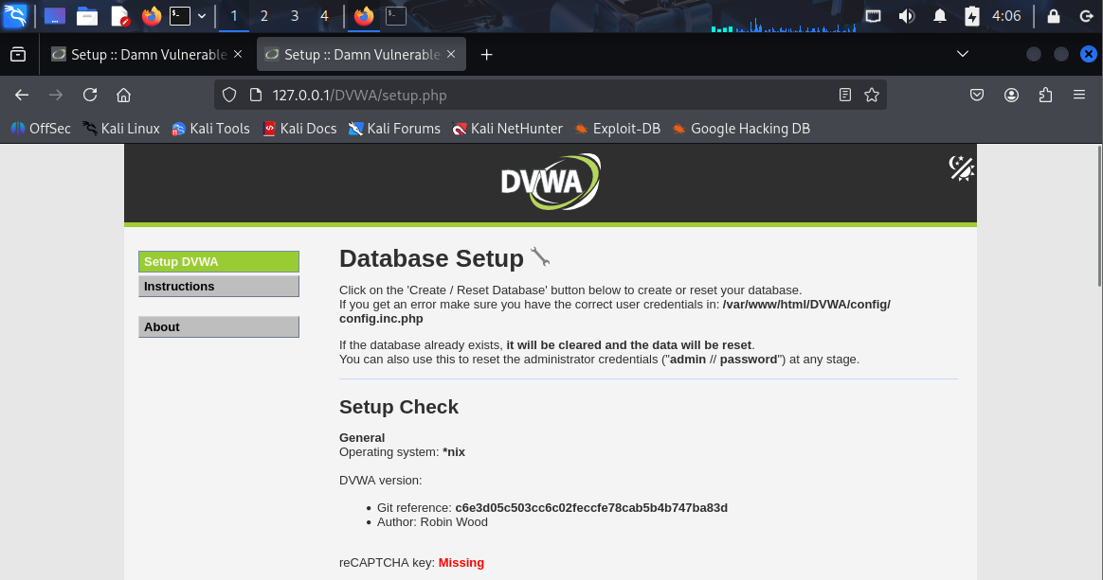  
  
Then go to: http://<your-server-ip>/DVWA/login.php

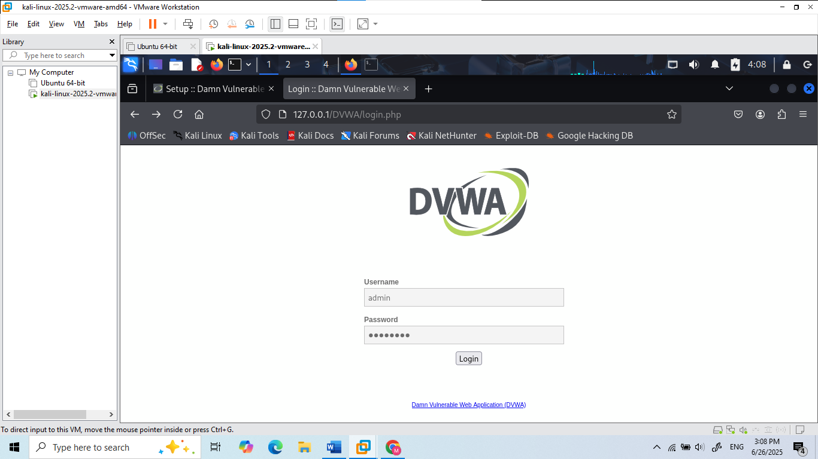

Login with:  
Username: admin  
Password: password 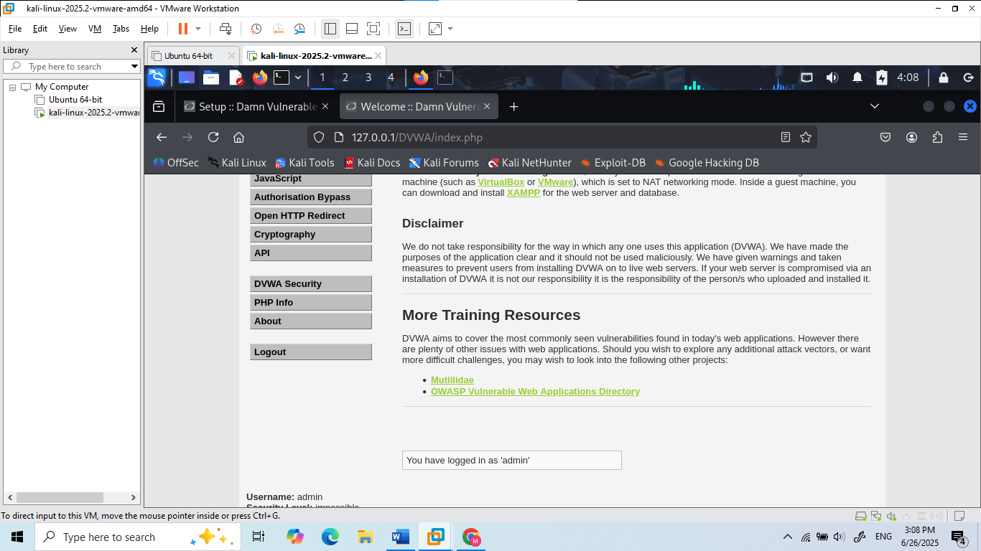

# Step 8: Verification & Tasks

- Screenshot the DVWA login page  
- Log in and set security level to 'low'

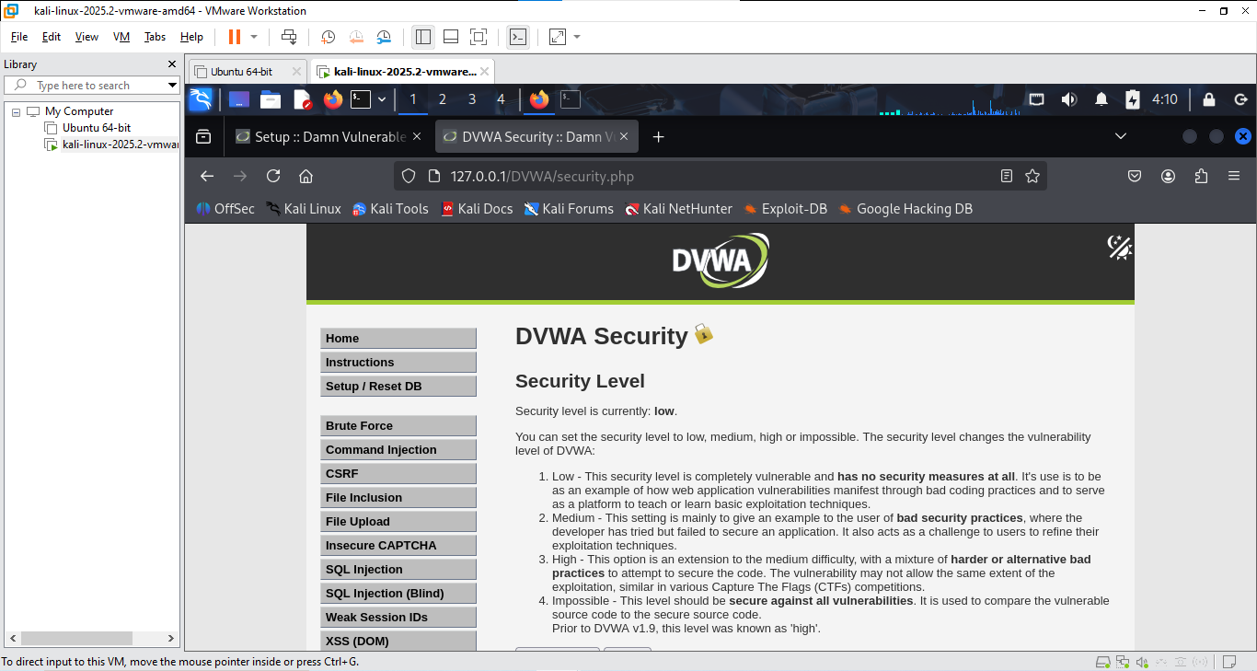  
- Write a short reflection on why DVWA is insecure by design

# PART 2. Deploying the website on 2 servers

**Network Configuration**

Example configuration (Students need to check the IP address of the Server):  
- Web Server: 192.168.1.20  
- Database Server: 192.168.1.30

**Step 1: Configure Database Server**

1. Update packages and install MariaDB:  
 sudo apt update && sudo apt install mariadb-server -y  
  
2. Start and enable MariaDB:  
 sudo systemctl enable mariadb  
 sudo systemctl start mariadb

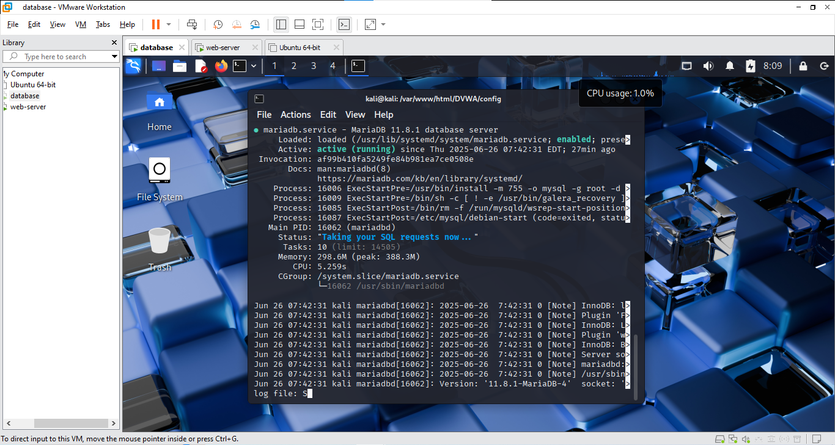  
  
3. Configure the DVWA database:  
 sudo mysql  
  
 CREATE DATABASE dvwa;  
 CREATE USER 'dvwa'@'192.168.1.20' IDENTIFIED BY 'dvwa';  
 GRANT ALL PRIVILEGES ON dvwa.* TO 'dvwa'@'192.168.1.20';  
 FLUSH PRIVILEGES;  
 EXIT;

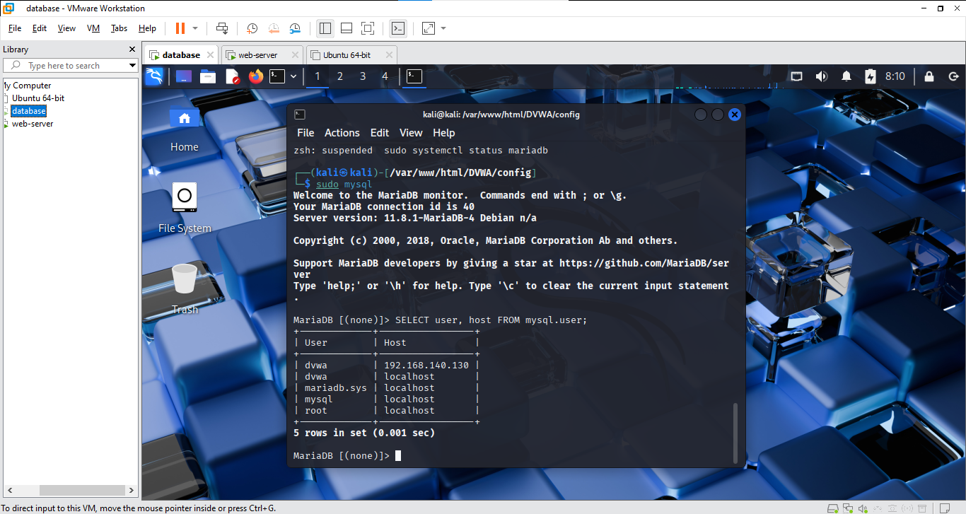

4. Allow remote connections:  
 sudo nano /etc/mysql/mariadb.conf.d/50-server.cnf  
 Change: bind-address = 0.0.0.0  
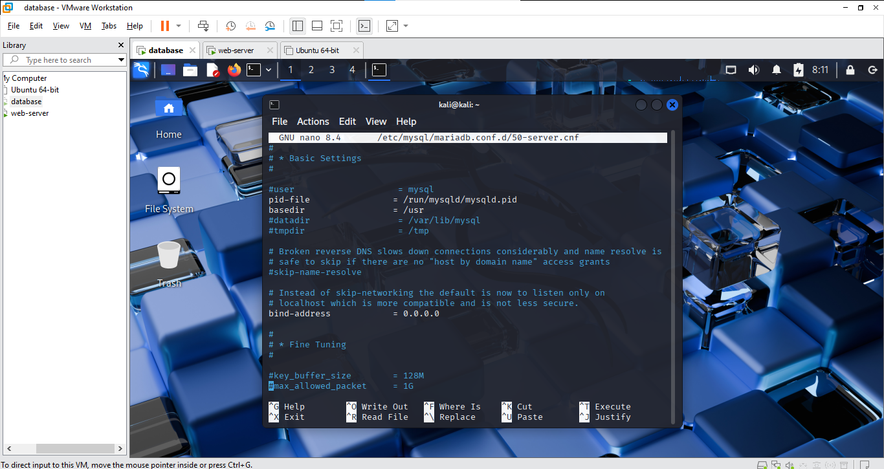  
 sudo systemctl restart mariadb

**Step 2: Configure Web Server**

1. Install Apache, PHP, and dependencies:  
 sudo apt update  
 sudo apt install apache2 php php-mysqli php-gd git -y  
  
2. Clone DVWA into web root:  
 cd /var/www/html  
 sudo git clone https://github.com/digininja/DVWA.git

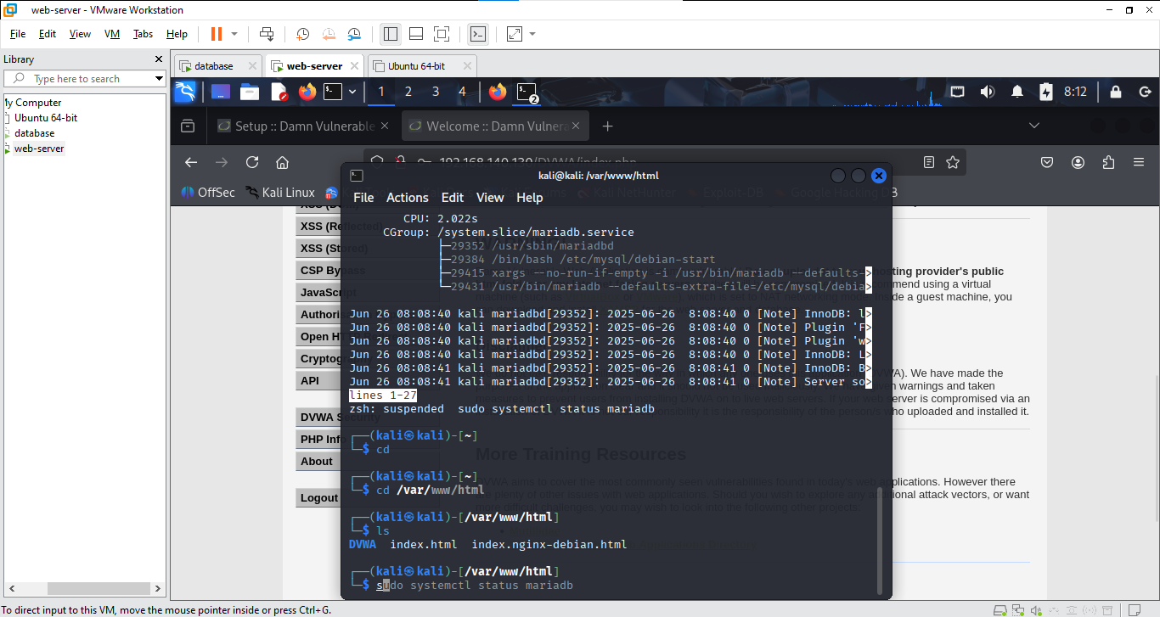  
  
3. Set permissions:  
 sudo chown -R www-data:www-data DVWA  
 sudo chmod -R 755 DVWA  
  
4. Configure DVWA:  
 cd DVWA/config  
 sudo cp config.inc.php.dist config.inc.php  
 sudo nano config.inc.php  
  
 Set:  
 $_DVWA[ 'db_server' ] = '192.168.1.30';  
 $_DVWA[ 'db_user' ] = 'dvwa';  
 $_DVWA[ 'db_password' ] = 'dvwa';  
 $_DVWA[ 'db_database' ] = 'dvwa';  
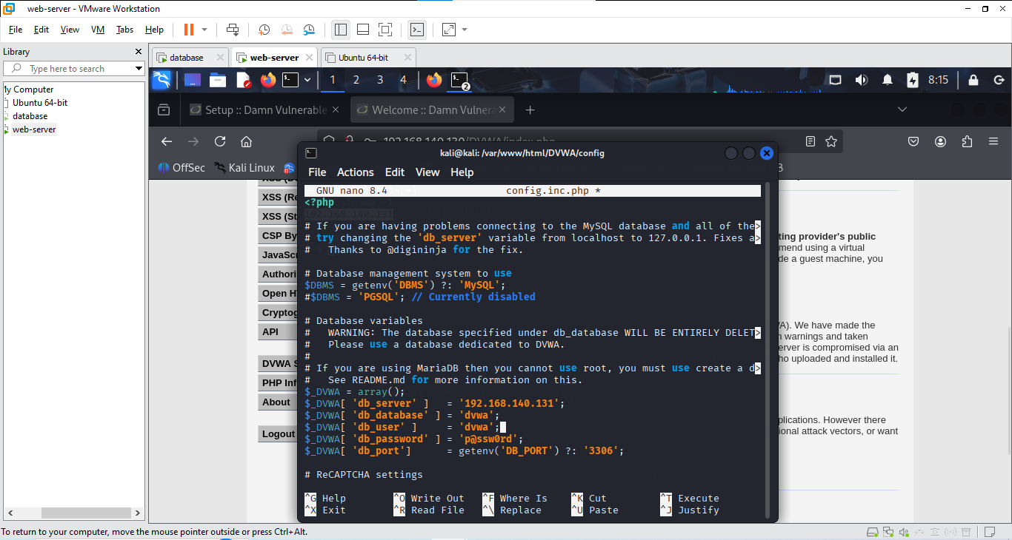  
 Ensure 'allow_url_include = On' in PHP config:  
 sudo nano /etc/php/8.4/apache2/php.ini

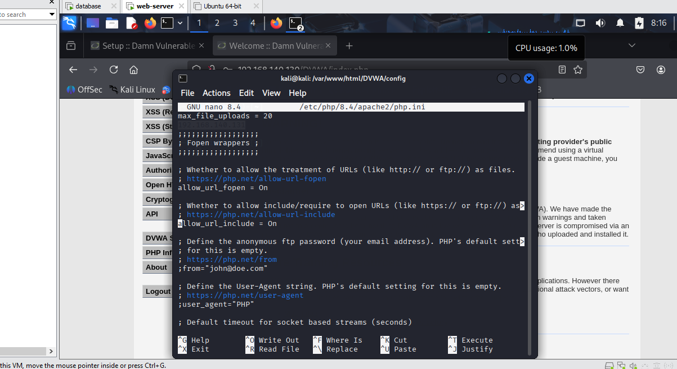  
 Then restart Apache:  
 sudo systemctl restart apache2

**Step 3: Verify Setup**

1. On the Web Server, open browser or client and visit:  
 http://192.168.1.20/DVWA/setup.php  
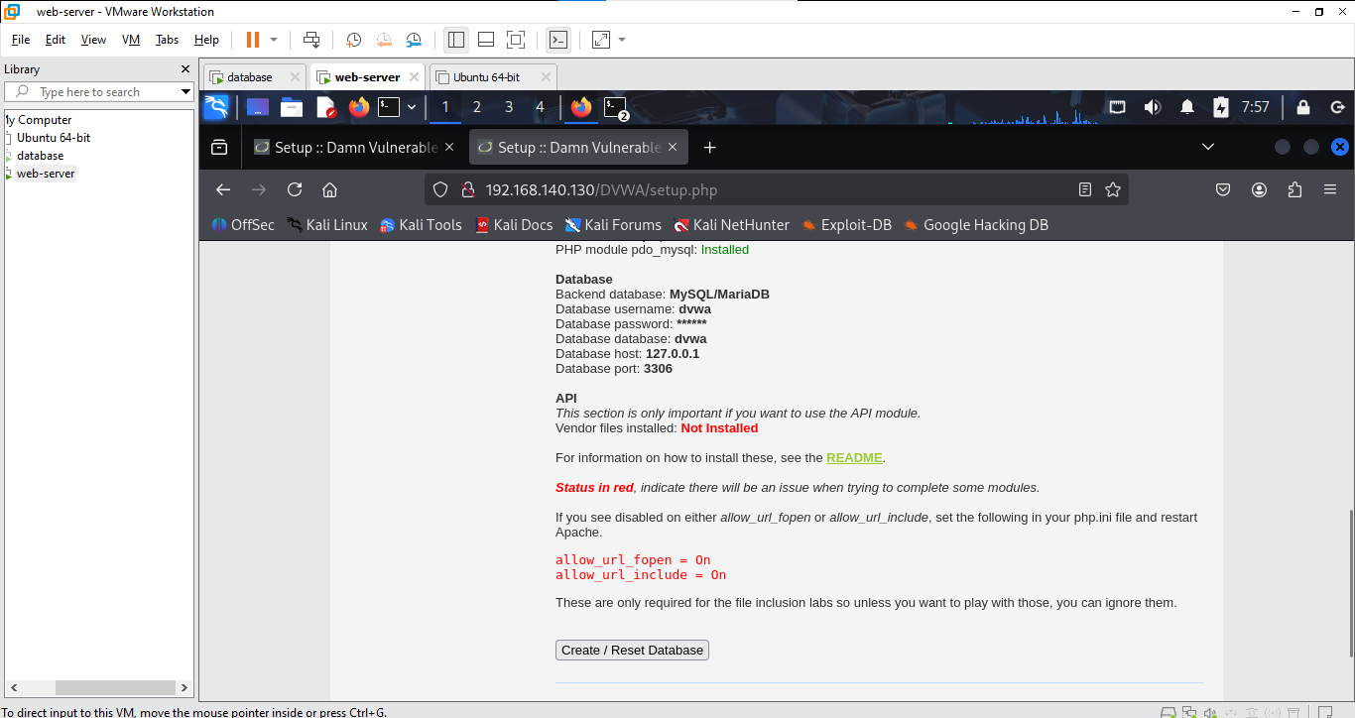  
2. Click 'Create / Reset Database'  
3. Then login at:  
 http://192.168.1.20/DVWA/login.php  
  
 Username: admin  
 Password: password

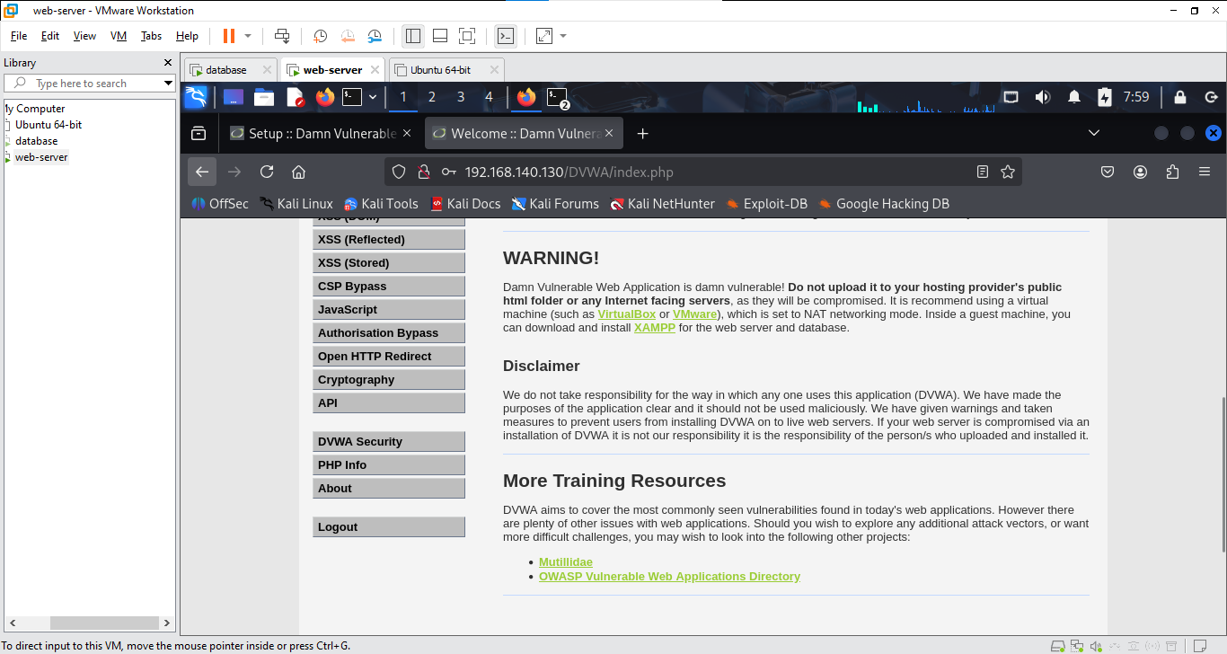

**Common Troubleshooting Tips**

- Ensure MySQL is listening on 0.0.0.0 s  
- Use `telnet 192.168.1.30 3306` from the Web Server to test DB connection  
- Check firewall (ufw or iptables) if services are blocked  
- Check Apache and MariaDB logs for error details

**Lab Report Submission**

# Students must submit: - Screenshot of MySQL configuration and DVWA login page - Evidence of IP setup and working DB connectivity - A short explanation of each configuration step